We invite women to join our Amazing and Healing Journey



We all have our story, we also have a beginning for new ways to move forward from barriers and limitations, to experience new skills/tools to cope with depression and life challenges.

**Community…**

How? Building new supportive relationships within a small group of women.

**Empowerment…**

Working together with a thoughtful caring team of peer led facilitators, who are trained and interested in moving forward using a very special life strengthens workbook.

If your answer is YES! and would like to know more about the Healing Pathways Program.

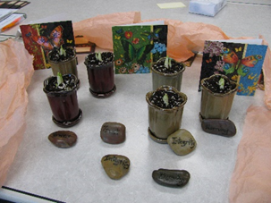

Call **DART Project**, leave a message at **503-988-6481** and **Jan** or **Angie** will return your call. We offer 14 weekly groups.

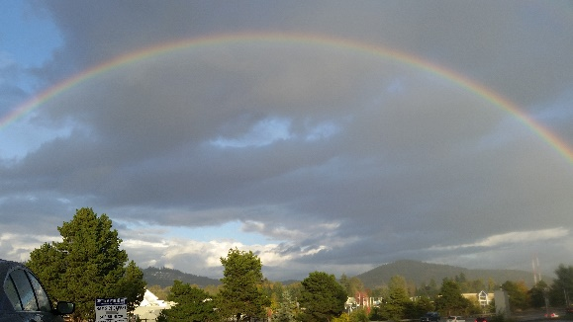

Ours is a strength and skills-building process, developed by and for women with disabilities intended to lead to Self-Growth and Wholeness.